Google Search Console (GSC) Assignment :
Task 1: Set Up Google Search Console and Verify Ownership
Objective
To add the DKV Foods website to Google Search Console and verify ownership using the HTML tag method.
Procedure
- Opened Google Search Console and logged in with a Google account.
- Added the DKV Foods website as a new property.
- Selected the URL Prefix property type.
- Entered:
https://dkvfoods.lovestoblog.com/
- Selected the HTML tag verification method.
- Google provided an HTML verification meta tag.
- The verification tag was added to the website's <head> section.
- Returned to Google Search Console and clicked Verify.
- The website was successfully connected to Google Search Console.
Result
The DKV Foods website was successfully added to Google Search Console and ownership was verified.
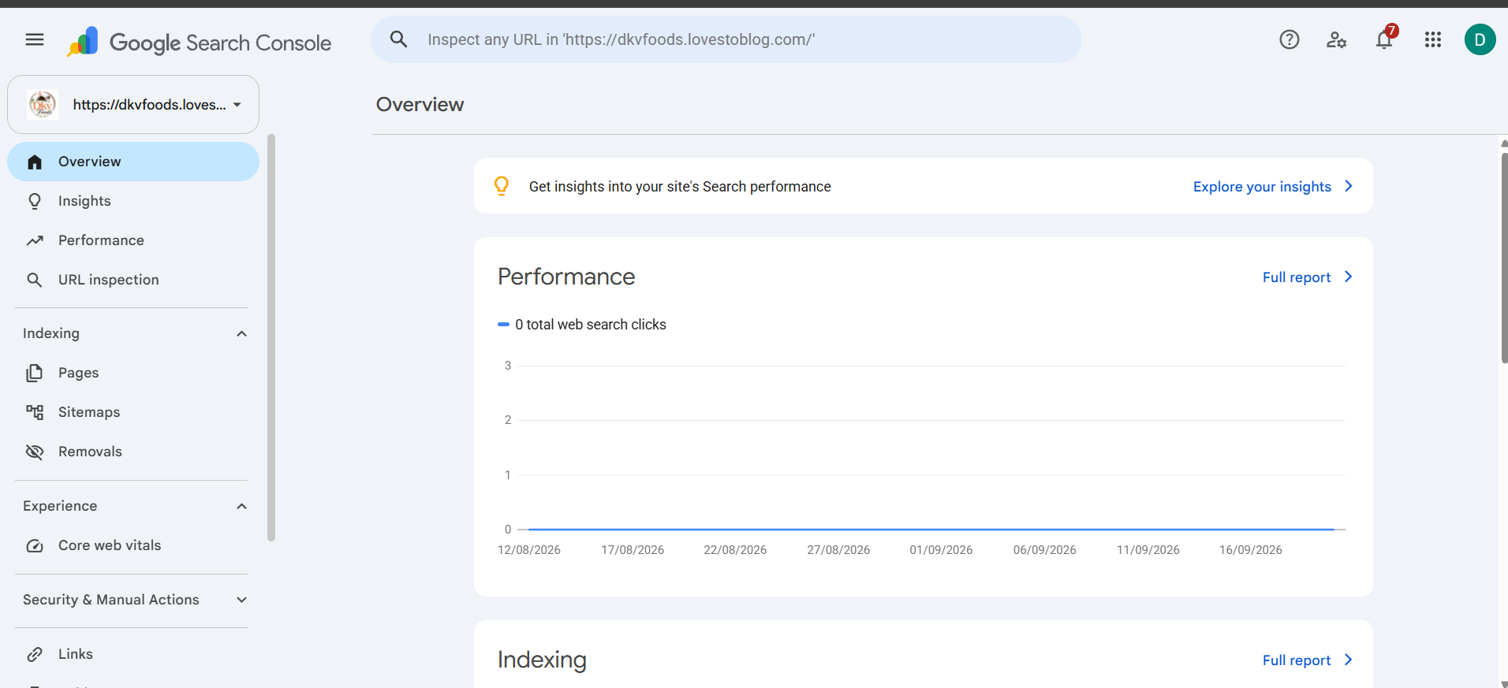
Task 2: Submit Sitemap in Google Search Console
Objective
To submit the website sitemap to Google Search Console so that Google can discover and process website URLs.
Sitemap Submitted
The WordPress sitemap used was:
https://dkvfoods.lovestoblog.com/wp-sitemap.xml
Procedure
- Opened Google Search Console.
- Selected the DKV Foods property.
- Opened Indexing → Sitemaps.
- Entered wp-sitemap.xml in the sitemap field.
- Clicked Submit.
- Google displayed the confirmation message "Sitemap submitted successfully."
Result
The sitemap was successfully submitted to Google Search Console. Google confirmed that it will periodically process the sitemap and look for changes.
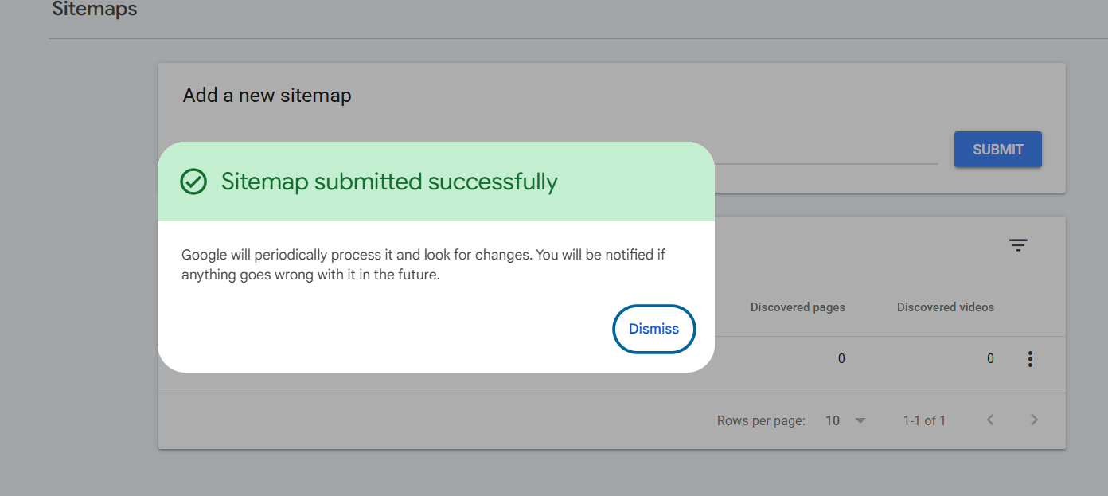
Task 3: Identify Top 3 Search Queries
Objective
To identify the top three search queries that brought users to the website during the last 28 days.
Procedure
- Opened Performance → Search results.
- Selected the Last 28 days date range.
- Selected Web as the search type.
- Checked the Performance report.
- Opened the Queries section.
- Checked the available search-query data.
Results
During the selected 28-day period, the website had:
- Total clicks: 0
- Total impressions: 5
- Average CTR: 0%
- Average position: 3.6
The Queries section did not display individual search queries.
Rank | Search Query | Clicks
1 | No query data available | 0
2 | No query data available | 0
3 | No query data available | 0
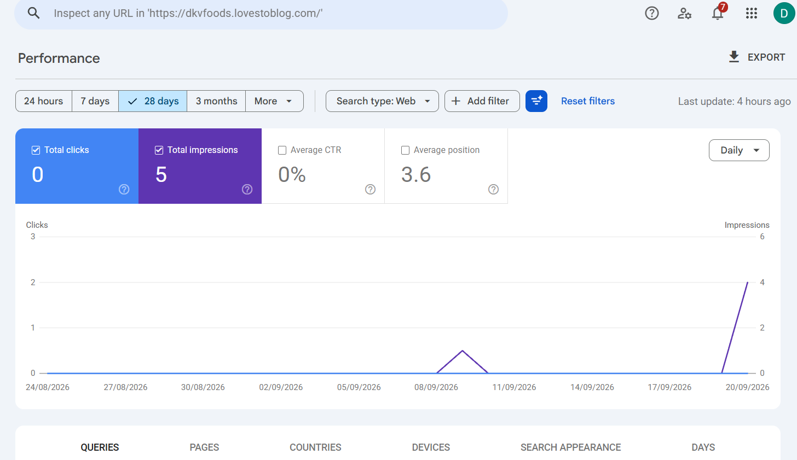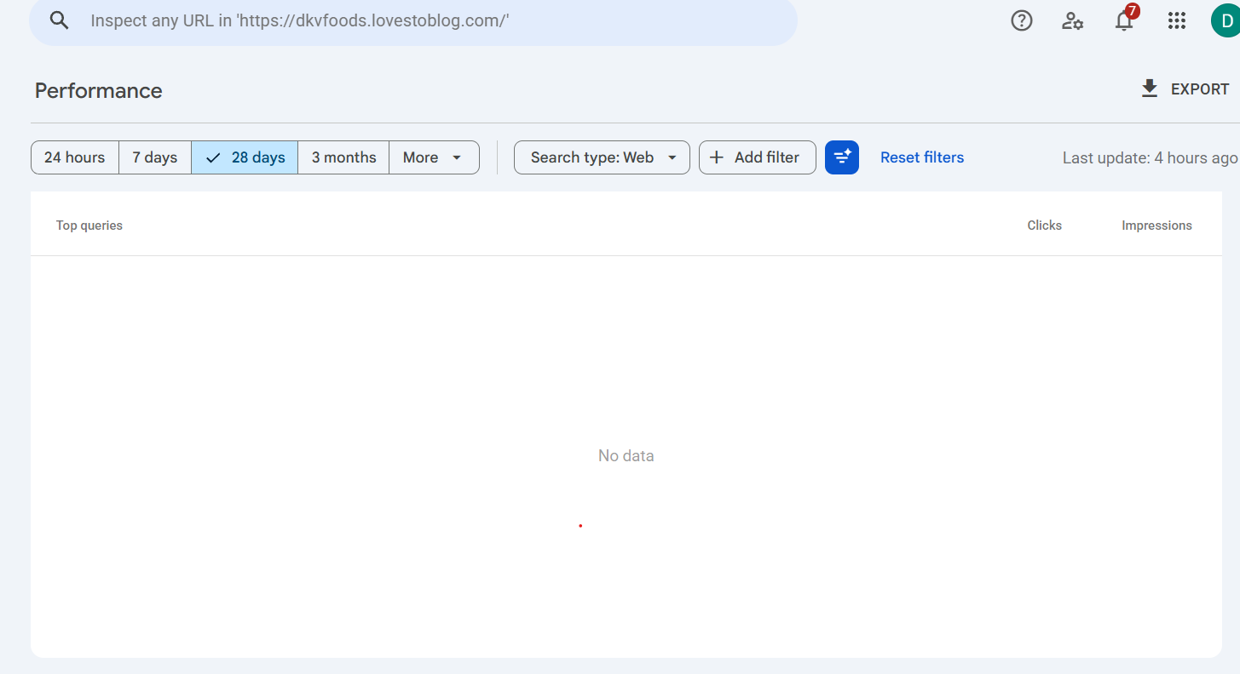

Task 4: URL Inspection and Request Indexing
Objective
To inspect a webpage using the Google Search Console URL Inspection tool and check its indexing status.
URL Inspected
https://dkvfoods.lovestoblog.com/
Procedure
- Opened the URL Inspection tool in Google Search Console.
- Entered the DKV Foods homepage URL.
- Google inspected the URL.
- The result showed "URL is on Google."
- The Page Indexing section showed "Page is indexed."
- The page was also confirmed to be served over HTTPS.
- Google detected 1 valid Breadcrumbs item.
- The Request Indexing option was available.
Result
The URL Inspection tool confirmed that the DKV Foods homepage is already indexed and can appear in Google Search results.
Issues and Suggestions
No major indexing issue was displayed on the URL Inspection screen.
Additional information shown by GSC:
- Page is indexed.
- Page is served over HTTPS.
- 1 valid Breadcrumbs item was detected.
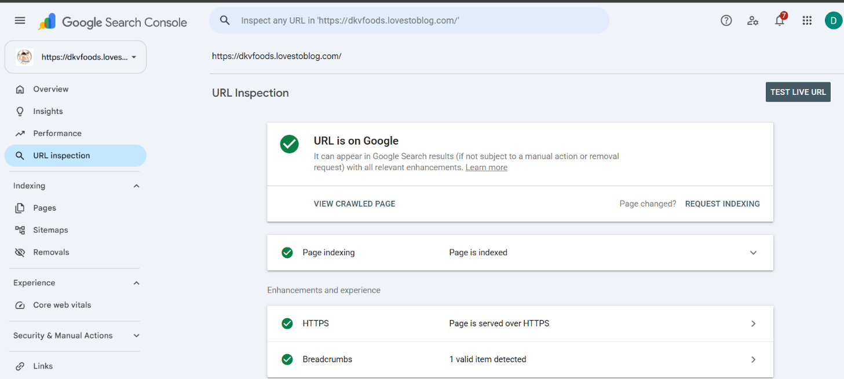
Conclusion
This assignment helped me understand the practical use of Google Search Console for SEO and website monitoring. I learned how to connect and verify a website, submit a sitemap, analyze search performance, inspect individual URLs, check indexing status, and use regular expressions to filter search queries.
The DKV Foods website was successfully added to Google Search Console, its sitemap was submitted, and its homepage was confirmed to be indexed by Google. The Performance report currently shows limited search data, which is expected for a website with limited search activity. Overall, Google Search Console is a useful tool for monitoring website visibility, indexing, and organic search performance.

